SPECIFICATIONS PLATFORM
Phase 3
Component Inventory & Design System

Deliverables 7–8 of 12
Prepared for Moses Mkhumbuza
Project Malls Specs — reusable specification portal
Contents 18 specimen plates · 59 components · 74 verified colour pairings
Ships with tokens.css · tailwind.tokens.js · tokens.ts · CONTRAST-REPORT.md
Date 7 August 2026
Status Awaiting approval to proceed to Phase 4

Confirmed in Phase 2
Split-pane variant A + B — panel widens to 58% above 1440px; attachments, revision history and related specifications render full-width beneath the split.
Landing opens with a compact hero above the browse surface.
Status vocabulary — Draft, In review, Published, Deprecated, Superseded.
Metadata is dynamic key/value pairs, authored per specification or inherited from a category template.

Contents
1. How this system is built
2. Foundations
S1 Colour — light mode
S2 Colour — dark mode
S3 Contrast — before and after
S4 Typography
S5 Spacing, radii and elevation
S6 Motion, focus, breakpoints and layering
S7 Grid, containers and the shell
3. Component inventory
4. Components
S8 Buttons
S9 Inputs and form controls
S10 Badges, status, tags and codes
S11 Cards
S12 Tables
S13 Navigation, sidebar, breadcrumbs and tabs
S14 Accordions, modals, sheets, tooltips and popovers
S15 Alerts and toasts
S16 Icons
S17 Empty, loading, error and skeleton states
S18 Theme applied — light and dark
5. Composition rules
6. Accessibility conformance
7. Token delivery
8. Phase 4 scope & approval

1. How this system is built
Three rules govern everything that follows. They are what make the system reusable rather than merely tidy.

1.1 Tokens are named by role, never by value
There is no token called "navy" or "blue-500". There is fg-muted, border-control, accent-subtle, brand-surface. A component asks for the role it needs and receives whatever the active theme binds to it. This is the single decision that makes dark mode cost one stylesheet block instead of a parallel component tree, and it is why plate S18 shows two themes rendered from identical markup.

1.2 Contrast is solved, not chosen
Every neutral step is derived by binary search against a contrast target rather than picked as an opacity that looked right. fg-muted is whatever composite of the ink over the surface reaches 7.2:1; fg-subtle is whatever reaches 4.65:1. The same function that produces those values produces the verification report that ships with the tokens, so the document and the code cannot drift apart.
This matters because it is exactly how the reference system went wrong. Its neutrals were chosen as opacities — 55% and 35% — which look reasonable and fail measurably.

1.3 The reference system’s character is preserved deliberately
This is a refinement, not a redesign, and the confirmed direction is to keep the split-pane and the visual language. So the navy-and-accent relationship, the two-curve motion vocabulary, the label-plus-flexing-rule section header, the bulleted specification row, the navigation selection marker and the reference-code chip all survive essentially unchanged. What changes is what was measurably broken: contrast, type floor, focus, semantics and state coverage.

What the numbers say
Reference system audit: 7 of 12 representative colour pairings fail WCAG 2.1 AA.
New palette: 0 failures across 74 pairings, light and dark.
Component inventory: 59 components — 6 retained unchanged, 8 extended, 8 rebuilt, 1 consolidated, 1 derived, 35 new.
The new components are not embellishment. They are the status, tags, revision history, attachments, related specifications, anchor navigation, print view, bookmarks, keyboard navigation, dark mode and the four system states your brief requires and the reference system does not have.

2. Foundations
The token layer. Everything in Section 4 is assembled from these values and references nothing else.

S1 Colour — light mode
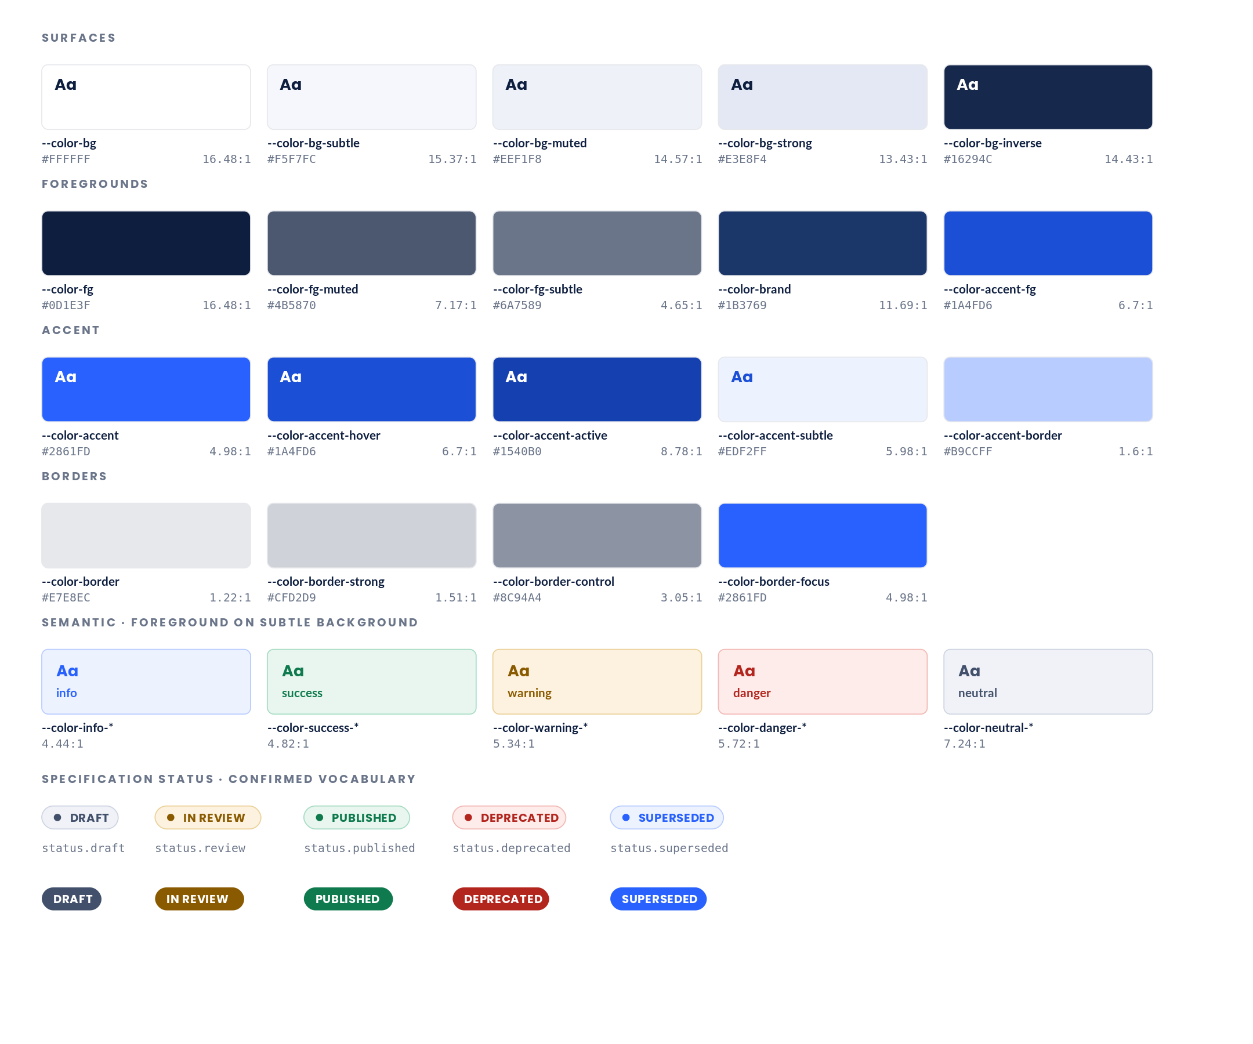
1 Every neutral is the ink colour composited over the surface, so the palette stays tonally unified — the single best property of the reference system, preserved exactly.  2 The neutral steps are solved for a contrast target rather than picked as an opacity. fg-muted lands at 7.2:1 and fg-subtle at 4.65:1, both against the base surface.  3 border-control is a separate token from border. Input and button boundaries must reach 3:1 under WCAG 1.4.11; decorative hairlines have no such requirement and stay subtle. |  | 4 Status uses the semantic scale rather than its own colours, so a new status needs no new palette.  5 Soft badges are the default. Solid badges are reserved for the specification action bar, where the badge sits against a tinted surface.

S2 Colour — dark mode
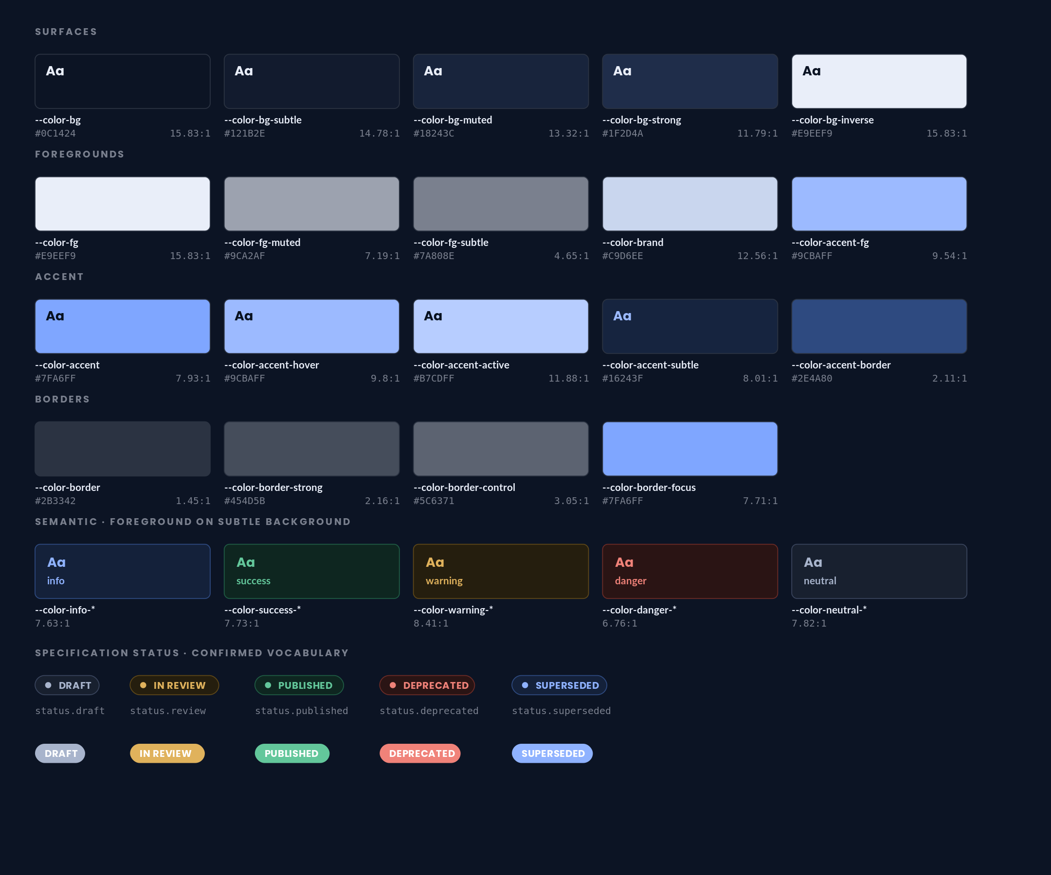
1 Dark mode is derived from the same token names, not a separate palette. Components reference --color-fg and never a literal, so nothing needs a dark variant.  2 Accent lightens to #7FA6FF because the light accent fails against a dark surface. Foreground-on-accent inverts to near-black.  3 The neutral ramp is solved against the dark base to the same targets — 7.2:1 and 4.65:1 — so the tonal rhythm matches light mode rather than merely inverting. |  | 4 Semantic backgrounds are deep tints of their hue rather than dark greys, so status remains identifiable at a glance.  5 Theme is set by a data-theme attribute, with prefers-color-scheme as the default. Both are emitted in tokens.css.

S3 Contrast — before and after
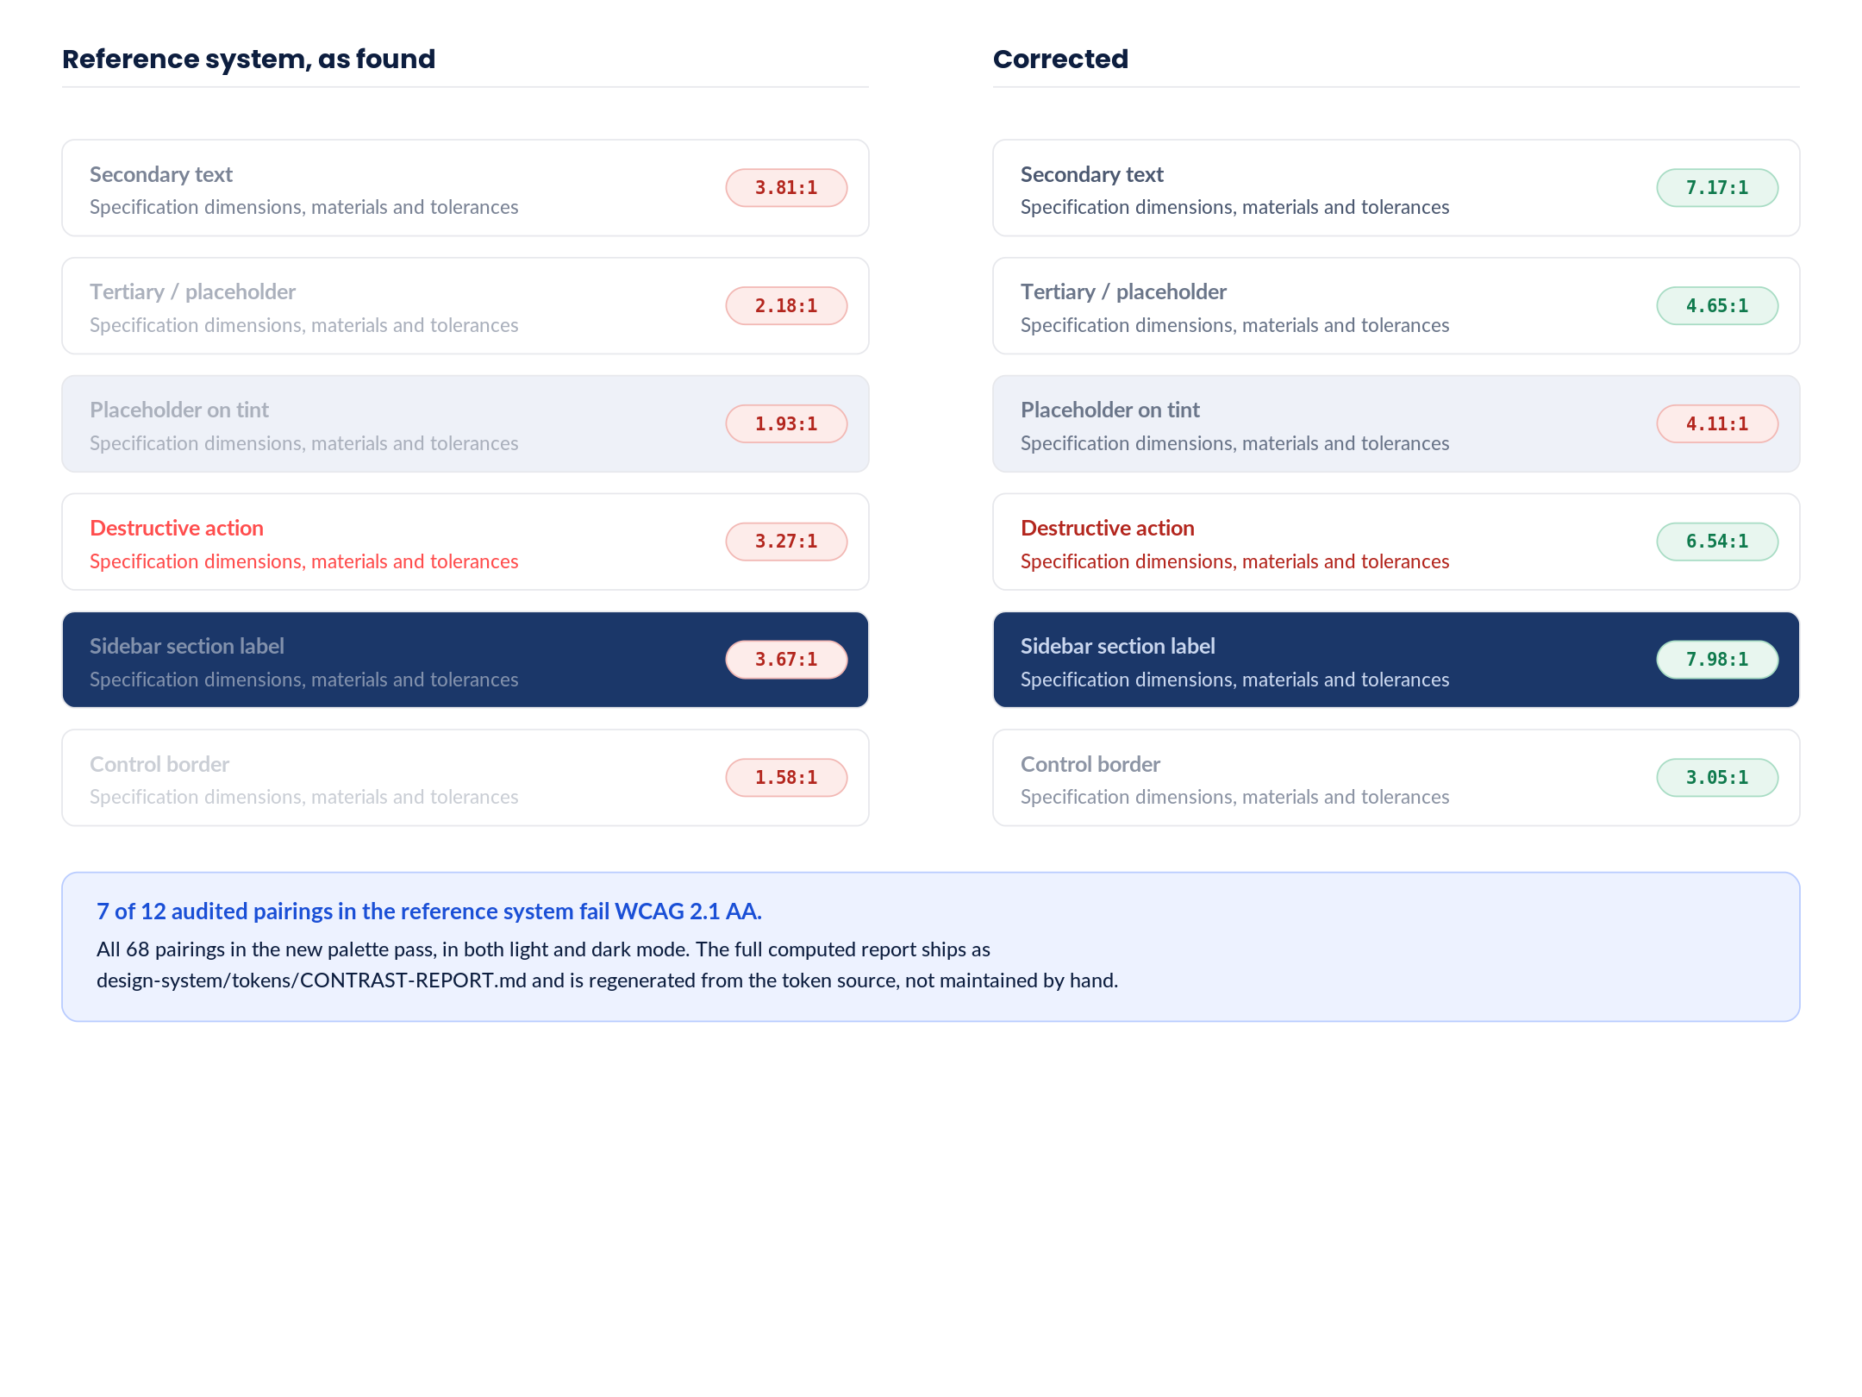
1 Each row shows the same role at the reference system's value and at the corrected value, with the computed ratio.  2 The tonal step between primary, secondary and tertiary text is preserved — the ramp is darkened rather than flattened, so the hierarchy reads the same.  3 The destructive red moves from #FF4D4D to a darker tone. This is the most visible change in the palette, and it only affects text and icons; a solid red fill can stay bright. |  | 4 The sidebar section label was the worst offender in the navigation at 3.67:1, because it sits at 8.5px as well as low contrast. It is corrected on both axes.  5 Ratios here are computed by the same function that generates the shipped report, so the document and the code cannot drift apart.

S4 Typography
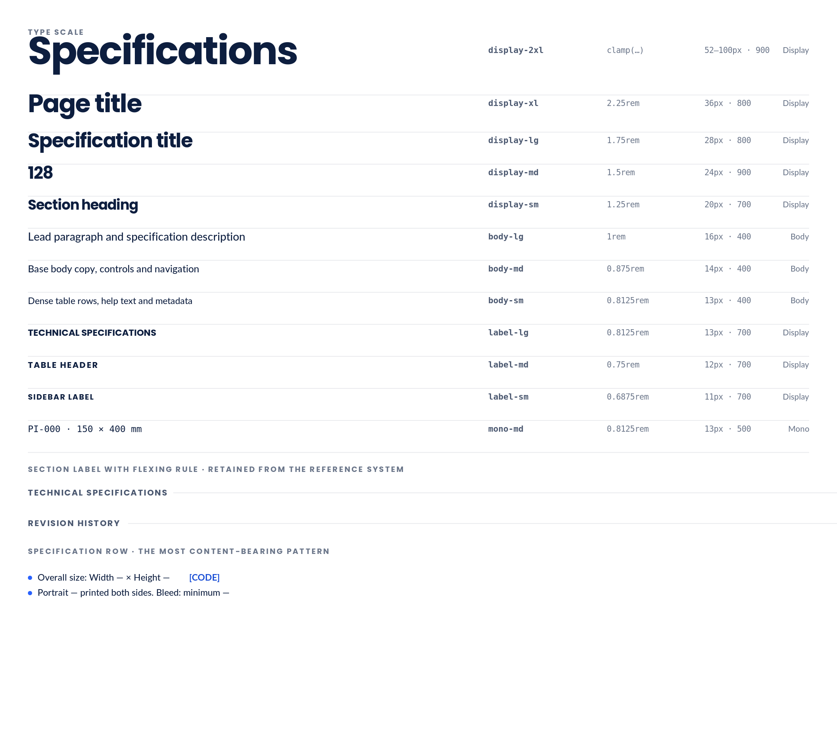
1 Two families, as in the reference system: a display face for headings, labels, numerals and chips, and a body face for copy, controls and navigation. A mono face is added for reference codes and dimensions, which the reference system sets in the body face.  2 The scale bottoms out at 11px, not 8px. label-sm replaces six separate roles that previously sat between 8px and 10px.  3 Base body size rises from 13px to 14px. Every step is expressed in rem so the scale responds to user font-size preferences. |  | 4 Tracking is retained: tight negative tracking on display sizes, wide positive tracking on uppercase labels. This is what gives the interface its character and it survives unchanged.  5 Specimens render in Poppins and Lato as stand-ins. The specified stack is Wix Madefor Display and Montserrat, with system fallbacks declared in tokens.css.

S5 Spacing, radii and elevation
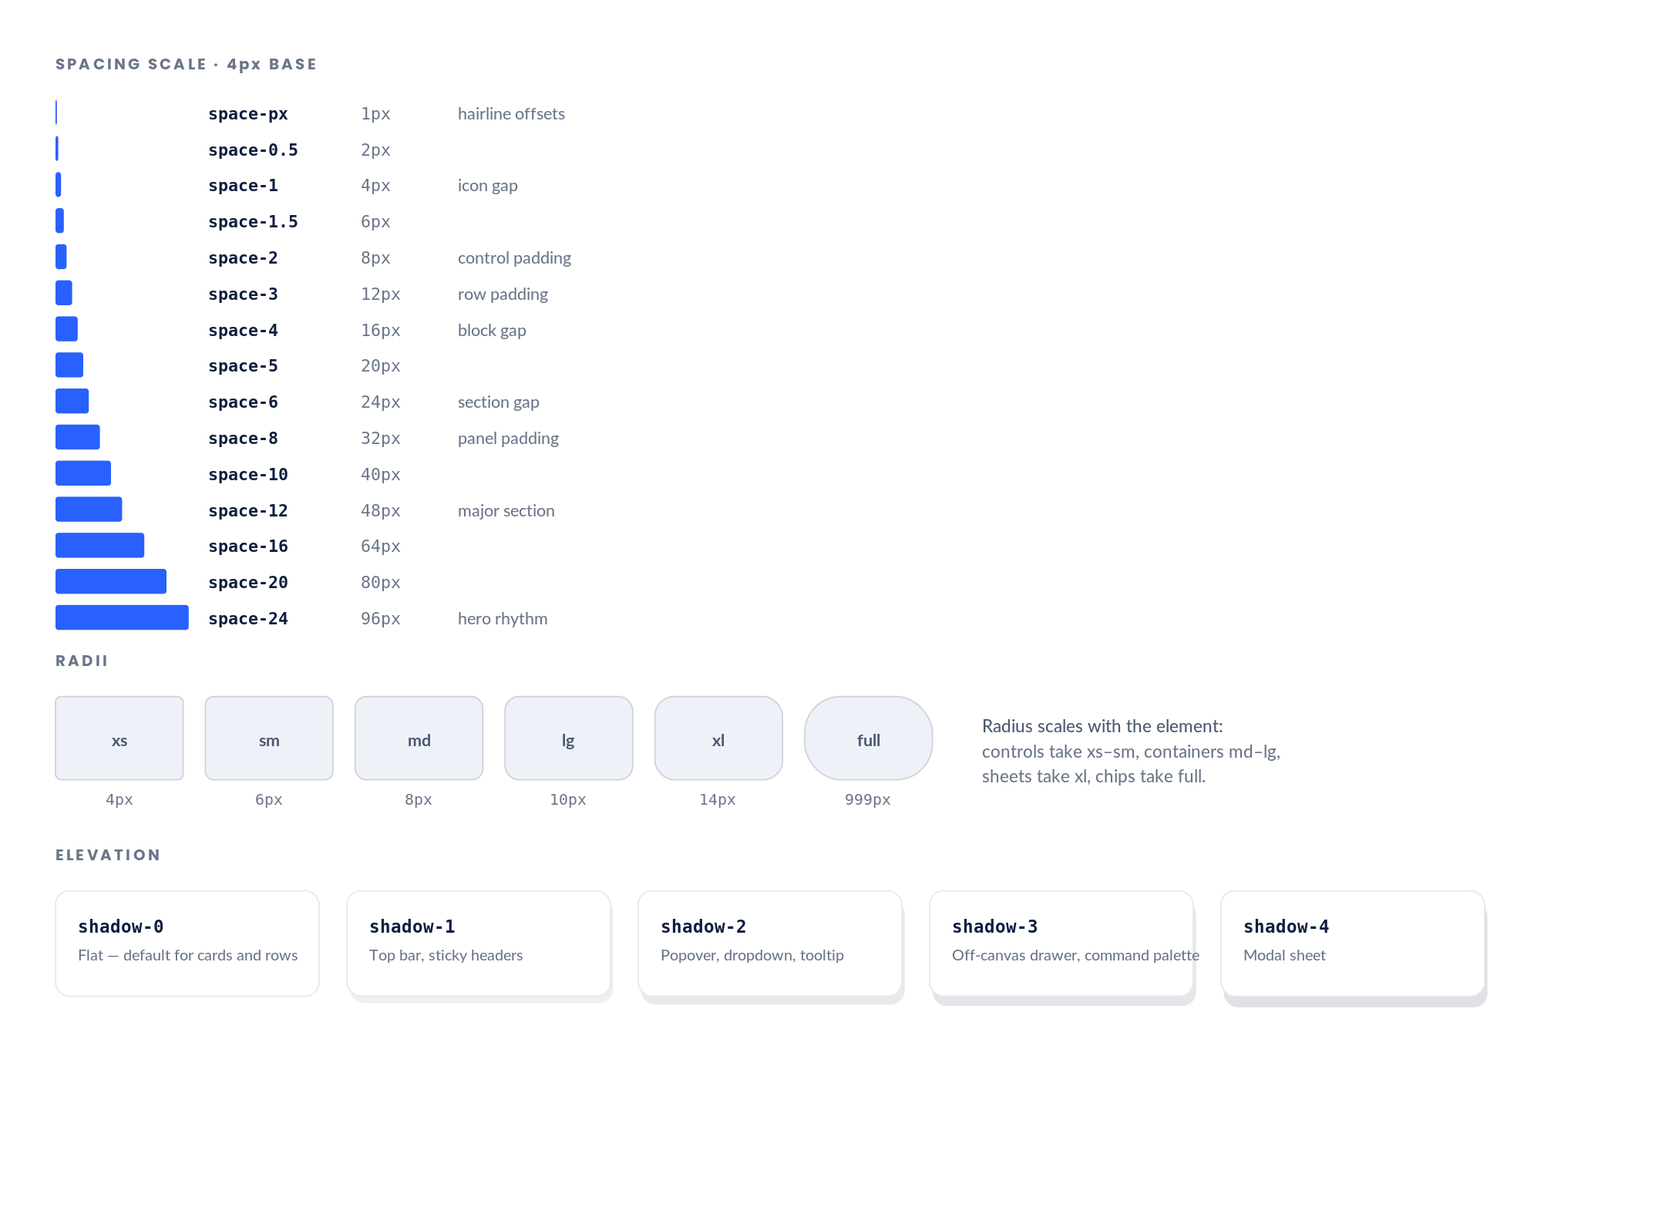
1 A formal 4px scale replaces the reference system's informal one. Seventeen values were in use there; all but five were already multiples of four, so imposing the scale causes almost no visual drift.  2 Half-steps at 2px and 6px are kept because the reference system's control padding depends on them.  3 Radii are unchanged from the reference system's observed values. The relationship — radius scales with element size — was already consistent and is now stated as a rule. |  | 4 Elevation is five levels where the reference system had three ad-hoc shadows. Level 0 is the default: cards and rows are flat, separated by borders rather than shadows.  5 Shadows are tinted with the ink colour rather than pure black, so they stay tonally consistent with the palette.

S6 Motion, focus, breakpoints and layering
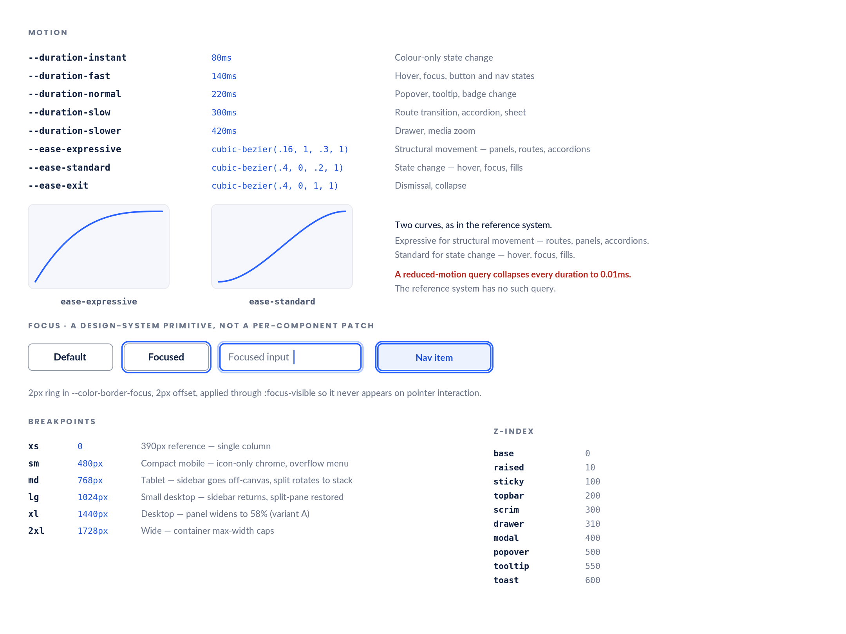
1 The two-curve vocabulary is retained exactly. It is the clearest piece of design thinking in the reference system.  2 Durations are formalised into five steps. The reference system clustered at 120–180ms and 280–350ms; those become fast and slow.  3 A prefers-reduced-motion query is added globally. This is a correction, not a refinement — the reference system plays every transition unconditionally. |  | 4 Focus is a single primitive applied through :focus-visible. The reference system suppresses default outlines through border and background resets without replacing them, leaving keyboard focus invisible in parts of the interface.  5 Layering is formalised into ten named steps. The reference system used four ad-hoc values between 140 and 400.

S7 Grid, containers and the shell
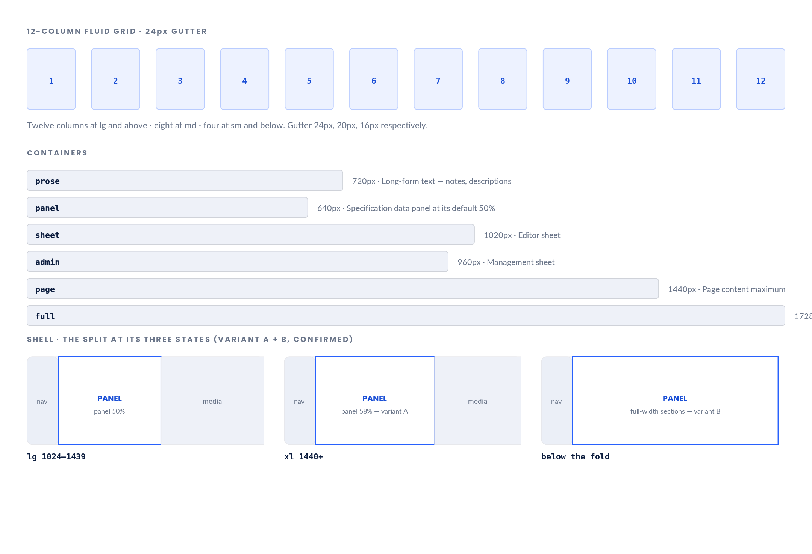
1 A twelve-column fluid grid governs the browse and landing surfaces. The specification detail view is not on the grid — it is a two-pane split, which is why the reference system needed no grid at all.  2 Container widths are named by purpose rather than size, so a component asks for the prose container rather than for 720px.  3 The prose container caps long-form notes at 720px, which is roughly 75 characters at body-md — the readable measure the reference system has no mechanism to enforce. |  | 4 Variant A: the panel widens from 50% to 58% at 1440px, using space the media pane does not need.  5 Variant B: attachments, revision history and related specifications render full-width beneath the split, so the split governs only the identity-and-technical fold.

2.8 Token reference

Colour — light
Token | Value | Token | Value
--color-bg | #FFFFFF | --color-brand-hover | #16294C
--color-bg-subtle | #F5F7FC | --color-brand-subtle | #EBEFF7
--color-bg-muted | #EEF1F8 | --color-brand-surface | #1B3769
--color-bg-strong | #E3E8F4 | --color-brand-surface-hover | #22437C
--color-bg-inverse | #16294C | --color-brand-on-surface | #FFFFFF
--color-fg | #0D1E3F | --color-brand-on-surface-muted | #C3D0E8
--color-fg-muted | #4B5870 | --color-info-fg | #2861FD
--color-fg-subtle | #6A7589 | --color-info-bg | #EDF2FF
--color-fg-on-accent | #FFFFFF | --color-info-border | #B9CCFF
--color-fg-on-inverse | #FFFFFF | --color-success-fg | #0F7A4D
--color-border | #E7E8EC | --color-success-bg | #E8F6EF
--color-border-strong | #CFD2D9 | --color-success-border | #A8DCC4
--color-border-control | #8C94A4 | --color-warning-fg | #8A5A00
--color-border-focus | #2861FD | --color-warning-bg | #FCF2DF
--color-accent | #2861FD | --color-warning-border | #EBD199
--color-accent-hover | #1A4FD6 | --color-danger-fg | #B3261E
--color-accent-active | #1540B0 | --color-danger-bg | #FDECEA
--color-accent-subtle | #EDF2FF | --color-danger-border | #F2B8B4
--color-accent-border | #B9CCFF | --color-neutral-fg | #42506B
--color-accent-fg | #1A4FD6 | --color-neutral-bg | #F0F2F7
--color-brand | #1B3769 | --color-neutral-border | #CDD4E2

Colour — dark
Token | Value | Token | Value
--color-bg | #0C1424 | --color-brand-hover | #E2EAF8
--color-bg-subtle | #121B2E | --color-brand-subtle | #16243F
--color-bg-muted | #18243C | --color-brand-surface | #111B2E
--color-bg-strong | #1F2D4A | --color-brand-surface-hover | #1A2842
--color-bg-inverse | #E9EEF9 | --color-brand-on-surface | #E9EEF9
--color-fg | #E9EEF9 | --color-brand-on-surface-muted | #A3B0C9
--color-fg-muted | #9CA2AF | --color-info-fg | #8FB2FF
--color-fg-subtle | #7A808E | --color-info-bg | #14213A
--color-fg-on-accent | #08111F | --color-info-border | #2E4A80
--color-fg-on-inverse | #0C1424 | --color-success-fg | #63C79B
--color-border | #2B3342 | --color-success-bg | #0E2620
--color-border-strong | #454D5B | --color-success-border | #1F5B44
--color-border-control | #5C6371 | --color-warning-fg | #E0B25C
--color-border-focus | #7FA6FF | --color-warning-bg | #251E0E
--color-accent | #7FA6FF | --color-warning-border | #5E4718
--color-accent-hover | #9CBAFF | --color-danger-fg | #F08279
--color-accent-active | #B7CDFF | --color-danger-bg | #2A1414
--color-accent-subtle | #16243F | --color-danger-border | #6B2B26
--color-accent-border | #2E4A80 | --color-neutral-fg | #A8B4CC
--color-accent-fg | #9CBAFF | --color-neutral-bg | #18202F
--color-brand | #C9D6EE | --color-neutral-border | #39445C

2.9 Scale reference

Type
Token | Size | px | Weight | Tracking | Leading | Family | Role
display-2xl | clamp(3.25rem, 8vw, 6.25rem) | 52–100 | 900 | -0.04em | 0.92 | Display | Landing headline
display-xl | 2.25rem | 36 | 800 | -0.03em | 1.1 | Display | Page title
display-lg | 1.75rem | 28 | 800 | -0.02em | 1.15 | Display | Specification title
display-md | 1.5rem | 24 | 900 | -0.03em | 1.0 | Display | Statistic numeral
display-sm | 1.25rem | 20 | 700 | -0.01em | 1.25 | Display | Section heading, sheet title
body-lg | 1rem | 16 | 400 | 0 | 1.6 | Body | Lead paragraph, description
body-md | 0.875rem | 14 | 400 | 0 | 1.6 | Body | Base — body copy, controls, nav
body-sm | 0.8125rem | 13 | 400 | 0 | 1.55 | Body | Dense rows, table cells, help text
label-lg | 0.8125rem | 13 | 700 | 0.08em | 1.2 | Display | Section label with rule
label-md | 0.75rem | 12 | 700 | 0.1em | 1.2 | Display | Table header, group label, chip
label-sm | 0.6875rem | 11 | 700 | 0.12em | 1.2 | Display | Smallest permitted — sidebar label
mono-md | 0.8125rem | 13 | 500 | 0 | 1.5 | Mono | Reference codes, dimensions, tokens

Spacing · radii · elevation · motion
Spacing | px | Radius | px | Motion token | Value
space-0 | 0px | radius-xs | 4px | --duration-instant | 80ms
space-px | 1px | radius-sm | 6px | --duration-fast | 140ms
space-0.5 | 2px | radius-md | 8px | --duration-normal | 220ms
space-1 | 4px | radius-lg | 10px | --duration-slow | 300ms
space-1.5 | 6px | radius-xl | 14px | --duration-slower | 420ms
space-2 | 8px | radius-full | 999px | --ease-expressive | cubic-bezier(.16, 1, .3, 1)
space-3 | 12px |  |  | --ease-standard | cubic-bezier(.4, 0, .2, 1)
space-4 | 16px |  |  | --ease-exit | cubic-bezier(.4, 0, 1, 1)
space-5 | 20px
space-6 | 24px
space-8 | 32px
space-10 | 40px
space-12 | 48px
space-16 | 64px
space-20 | 80px
space-24 | 96px

Breakpoints · layering · containers
Breakpoint | px | Behaviour | z-index | Value | Container | px
xs | 0 | 390px reference — single column | z-base | 0 | prose | 720px
sm | 480px | Compact mobile — icon-only chrome, overflow menu | z-raised | 10 | panel | 640px
md | 768px | Tablet — sidebar goes off-canvas, split rotates to stack | z-sticky | 100 | sheet | 1020px
lg | 1024px | Small desktop — sidebar returns, split-pane restored | z-topbar | 200 | admin | 960px
xl | 1440px | Desktop — panel widens to 58% (variant A) | z-scrim | 300 | page | 1440px
2xl | 1728px | Wide — container max-width caps | z-drawer | 310 | full | 1728px
 |  |  | z-modal | 400
 |  |  | z-popover | 500
 |  |  | z-tooltip | 550
 |  |  | z-toast | 600

3. Component inventory
Deliverable 7. 59 components across seven groups. This table is the source of truth for the Phase 5 build — every component listed here becomes a directory under /components with its own types, stories and tests.

Origin key
Origin | Meaning | Count
Retained | Exists in the reference system and carries over essentially unchanged. | 6
Extended | Exists in the reference system but gains variants, states or accessibility behaviour. | 8
Consolidated | Several inconsistent treatments in the reference system merged into one component. | 1
Rebuilt | Exists in the reference system but is re-implemented because its current form has a structural defect. | 8
Derived | New, but built from an existing reference-system pattern so it looks native. | 1
New | No precedent in the reference system. Required by the brief. | 35

Primitive — 6 components
Component | Variants | States | Key props | Accessibility obligation | Origin
Button | primary · brand · secondary · subtle · ghost · danger · danger-ghost | default · hover · active · focus · disabled · loading | variant, size, iconStart, iconEnd, loading, disabled, as | 44×44 touch target; aria-disabled not disabled when a reason exists | Consolidated
IconButton | same seven variants | default · hover · active · focus · disabled | icon, label (required), variant, size | Accessible name required by type; tooltip on hover and focus | New
Link | inline · standalone · quiet | default · hover · focus · visited | href, external, underline | External links announce the new context | New
Icon | 32 names · 16 / 20 / 24px | — | name, size, title | aria-hidden when decorative; title when meaningful | New
Spinner | sm · md · lg | — | size, delayMs (default 400) | role=status with a polite live region | New
VisuallyHidden | — | — | children | Carries skip links and screen-reader-only labels | New

Form — 11 components
Component | Variants | States | Key props | Accessibility obligation | Origin
TextField | text · email · url · number · password | default · hover · focus · filled · error · disabled · readonly | label, placeholder, help, error, required, prefix, suffix | Label always associated; error via aria-describedby and aria-invalid | Extended
Textarea | fixed · auto-grow · line-per-item | same seven | rows, maxRows, hint | Line-per-item variant documents its ** sub-heading convention in help text | Extended
Select | native · searchable | same seven | options, groups, placeholder, onCreate | Native under the hood; the searchable variant is a listbox with aria-activedescendant | Extended
Combobox | single · multiple | same seven | options, onSearch, onCreate, loading | Full combobox pattern; results announce a count | New
TagInput | — | default · focus · error · disabled | value, onAdd, onRemove, suggestions, max | Each chip removable by keyboard; removal announced | New
Checkbox | single · group | unchecked · checked · indeterminate · focus · disabled | checked, indeterminate, label, description | Indeterminate drives the table select-all | New
Radio | group | unselected · selected · focus · disabled | options, name, orientation | Arrow-key roving within the group | New
Switch | — | off · on · focus · disabled | checked, label | role=switch with aria-checked; never the only signal | Extended
DropZone | media · attachment | idle · drag-over · uploading · error | accept, multiple, maxSize, onDrop | Keyboard-reachable file input beneath; progress announced politely | Extended
Field | — | — | label, help, error, required, children | The wrapper that guarantees label association and reserves the error row | New
FormActions | inline · pinned | — | primary, secondary, dirty | Pinned variant stays reachable on long forms; guards unsaved changes | New

Data display — 12 components
Component | Variants | States | Key props | Accessibility obligation | Origin
Badge | soft · solid · 5 semantic tones | — | tone, dot, size | Dot or icon accompanies colour so tone is never colour-alone | Derived
StatusBadge | draft · review · published · deprecated · superseded | — | status, showLink | Superseded requires and announces its replacement link | New
Tag | static · removable | default · hover · focus | label, onRemove, href | Removable tags expose a labelled remove control | New
CodeChip | — | default · copyable | code, copyable | Copy action confirms through a toast | Retained
Card | specification · media · stat · boxed group | default · hover · selected · disabled | elevation, selected, as, href | One link target, one focus stop; no nested interactives | New
SpecRow | row · sub-heading · two-column | — | text, reference, level | The reference system's core content pattern, carried over unchanged | Retained
DefinitionList | single · two-column | — | items (dynamic key/value), emptyValue | Real dl/dt/dd so pairs are announced as pairs | New
Table | default · compact · stacked (below md) | loading · empty · error · populated | columns, rows, sort, selection, onSort, stickyHeader | thead, th scope, caption, aria-sort; stacked variant keeps semantics | Rebuilt
RevisionTable | — | empty · populated | revisions, onRestore | Empty state sits below the header, not in place of it | New
AttachmentList | grid · list | empty · populated · uploading | files, onRemove, kinds | File type and size announced with the name | New
MediaFrame | primary · thumbnail · rail | empty · loading · loaded · error | src, alt, ratio, zoomable | Aspect ratio reserved; alt required; lazy below the fold | Extended
Stat | — | — | value, label | Empty value renders an em dash, not zero | Retained

Navigation — 9 components
Component | Variants | States | Key props | Accessibility obligation | Origin
Sidebar | docked · off-canvas | open · closed | sections, selectedId, onSelect, filterQuery | Closed off-canvas is unmounted and inert; focus trapped when open | Rebuilt
NavTree | category · sub-group · leaf | default · hover · selected · expanded · focus | nodes, expandedIds, selectedId | Roving tab index; aria-expanded; collapsed branches unmounted | Rebuilt
TopBar | desktop · compact | — | breadcrumbs, actions, onMenuToggle | Contains the skip-link target | Extended
Breadcrumbs | full · truncated · back-only | — | trail, maxItems | nav with an ordered list and aria-current on the last item | Rebuilt
AnchorRail | horizontal · scrollable | default · active | sections, activeId | Scroll-spy with aria-current; keyboard-reachable, never scroll-only | New
Tabs | underline · pill | default · active · focus · disabled | tabs, activeId, onChange | Full tabs pattern with arrow-key navigation | Extended
Pagination | numbered · load-more | — | page, pageCount, pageSize, onChange | Page changes announced; rows-per-page is a labelled control | New
CommandPalette | overlay · full-screen (below md) | closed · empty · searching · results · no-results | onSearch, recents, groups | Focus trapped, Escape restores, results announce a count | New
SkipLink | — | hidden · focused | targetId | First focusable element on every page | New

Overlay — 6 components
Component | Variants | States | Key props | Accessibility obligation | Origin
Modal | dialog · confirm · destructive-confirm | closed · open | title, size, onClose, initialFocus | Focus trapped, scroll locked, Escape closes, focus restored | Rebuilt
Sheet | bottom (mobile) · side · full-bleed | closed · open · dragging | side, snapPoints | The mobile presentation of Modal — same semantics | New
Popover | menu · form · info | closed · open | trigger, placement, offset | Takes focus; Escape returns it to the trigger | New
Tooltip | — | hidden · visible | content, placement, delay | Opens on hover and focus; never interactive; never sole source | New
Menu | actions · overflow · select | closed · open · item-focused | items, onSelect | Full menu pattern with type-ahead and arrow keys | New
Scrim | — | hidden · visible | onDismiss, blur | aria-hidden; click and Escape both dismiss | Retained

Feedback — 6 components
Component | Variants | States | Key props | Accessibility obligation | Origin
Alert | info · success · warning · danger | static · dismissible | tone, title, action, onDismiss | Icon plus leading bar so tone is never colour-alone | New
Toast | info · success · warning · danger | entering · visible · paused · leaving | tone, message, action, duration | Polite live region; pauses on hover and focus | New
EmptyState | no-data · filtered · no-results · no-access | — | title, description, action, icon | Always carries the action that resolves it | New
ErrorState | inline · page · boundary | — | title, message, reference, onRetry | Retry offered; reference surfaced for support | New
Skeleton | text · row · card · media | — | lines, width, ratio | Reserves resolved dimensions; shimmer respects reduced-motion | New
ProgressBar | determinate · indeterminate | — | value, label | role=progressbar with value text | New

Layout — 9 components
Component | Variants | States | Key props | Accessibility obligation | Origin
AppShell | — | — | sidebar, topbar, children | Landmark regions: banner, navigation, main, contentinfo | Rebuilt
SplitPane | 50 / 50 · 58 / 42 (xl) · stacked (below lg) · rail-collapsed | — | panel, media, collapsed | Reading order is panel-first in the DOM at every width | Rebuilt
Container | prose · panel · sheet · admin · page · full | — | size, as | Caps measure at roughly 75 characters | New
Grid | 12 / 8 / 4 column | — | cols, gap, responsive | — | New
Stack | vertical · horizontal | — | gap, align, wrap | — | New
SectionBlock | — | — | label, children, anchorId | Renders the label-plus-flexing-rule header and registers with the anchor rail | Retained
Accordion | single · multiple | collapsed · expanded · focus | items, defaultExpanded | Measured height, no ceiling; collapsed content unmounted | Rebuilt
DownloadBar | — | empty · populated | files, actions | Pinned at every breakpoint; the one element that never moves | Retained
FilterPanel | rail · sheet (below md) | collapsed · expanded · active | groups, value, onChange, onClear | Active filter count announced; clear-all always reachable | New

4. Components
Specimens for every component family, with the reasoning behind each decision. Variants, states and props are catalogued in Section 3.

S8 Buttons
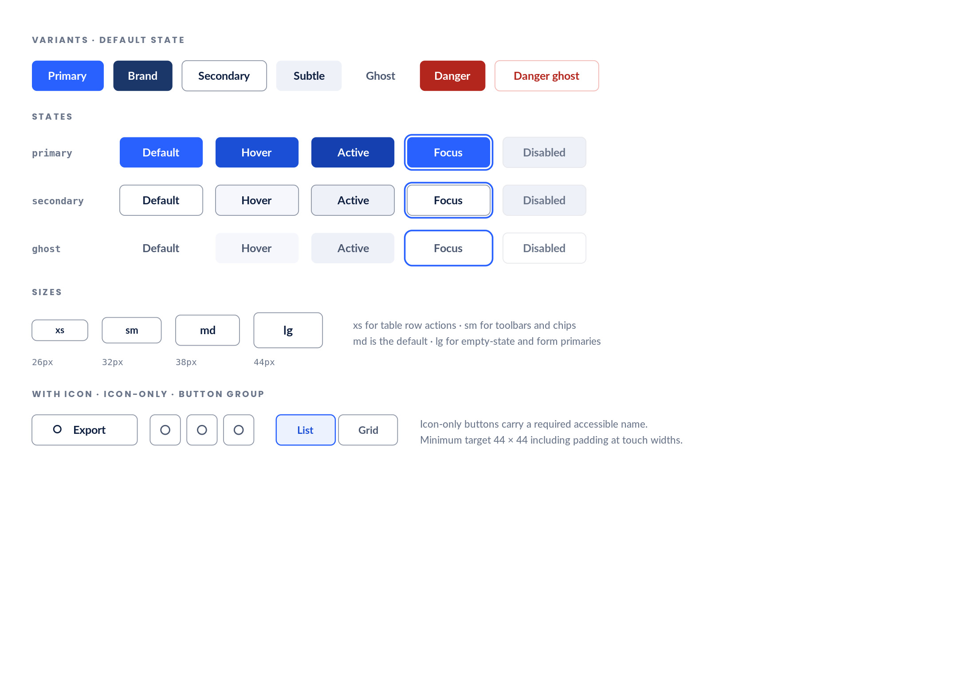
1 Seven variants. The reference system had four inconsistent treatments; these consolidate them and add the two danger forms it lacked.  2 Five states on every variant, including the focus ring the reference system never defines.  3 Four sizes on a 26 / 32 / 38 / 44 ladder, derived from the control heights already in use — 26 for admin row actions, 32 for toolbars, 38 default, 44 for primary form actions. |  | 4 Disabled uses a muted fill with subtle foreground and is never the only signal — disabled controls carry aria-disabled and a tooltip explaining why.  5 At touch widths every button reaches a 44 × 44 target through padding, without changing its visual height.

S9 Inputs and form controls
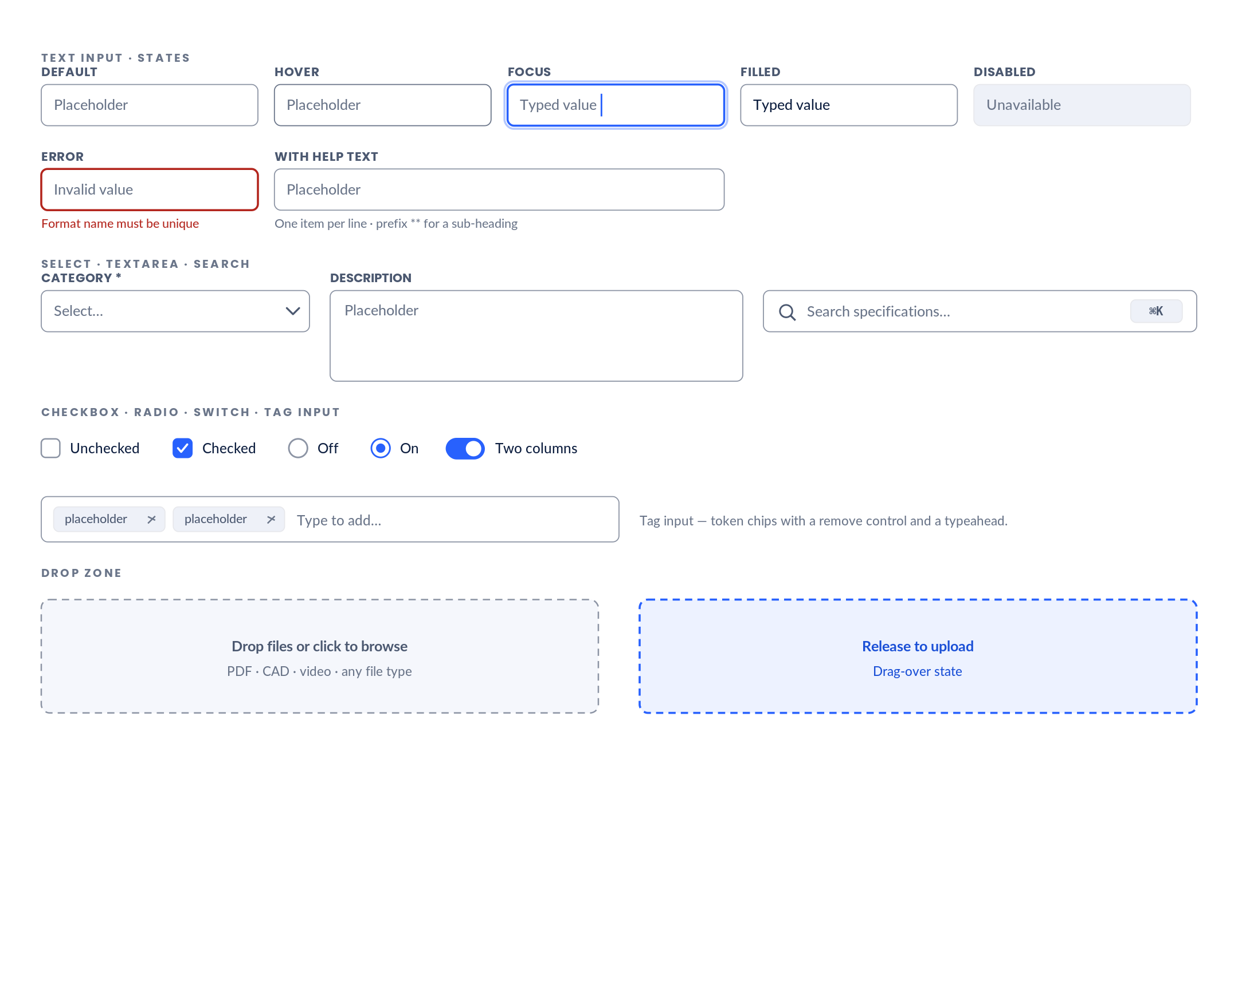
1 Six states per field. The reference system defines default and focus only, with focus signalled by a border colour that does not reach 3:1.  2 border-control gives every field boundary a 3:1 minimum, satisfying WCAG 1.4.11 for non-text contrast.  3 Error state reserves its message row in the layout, so revealing an error never shifts the form. |  | 4 Labels sit above inputs at every width. This keeps association unambiguous and touch targets full-width on mobile.  5 The tag input and drag-over state are net-new; the reference system has drop zones but no visible drag feedback.

S10 Badges, status, tags and codes
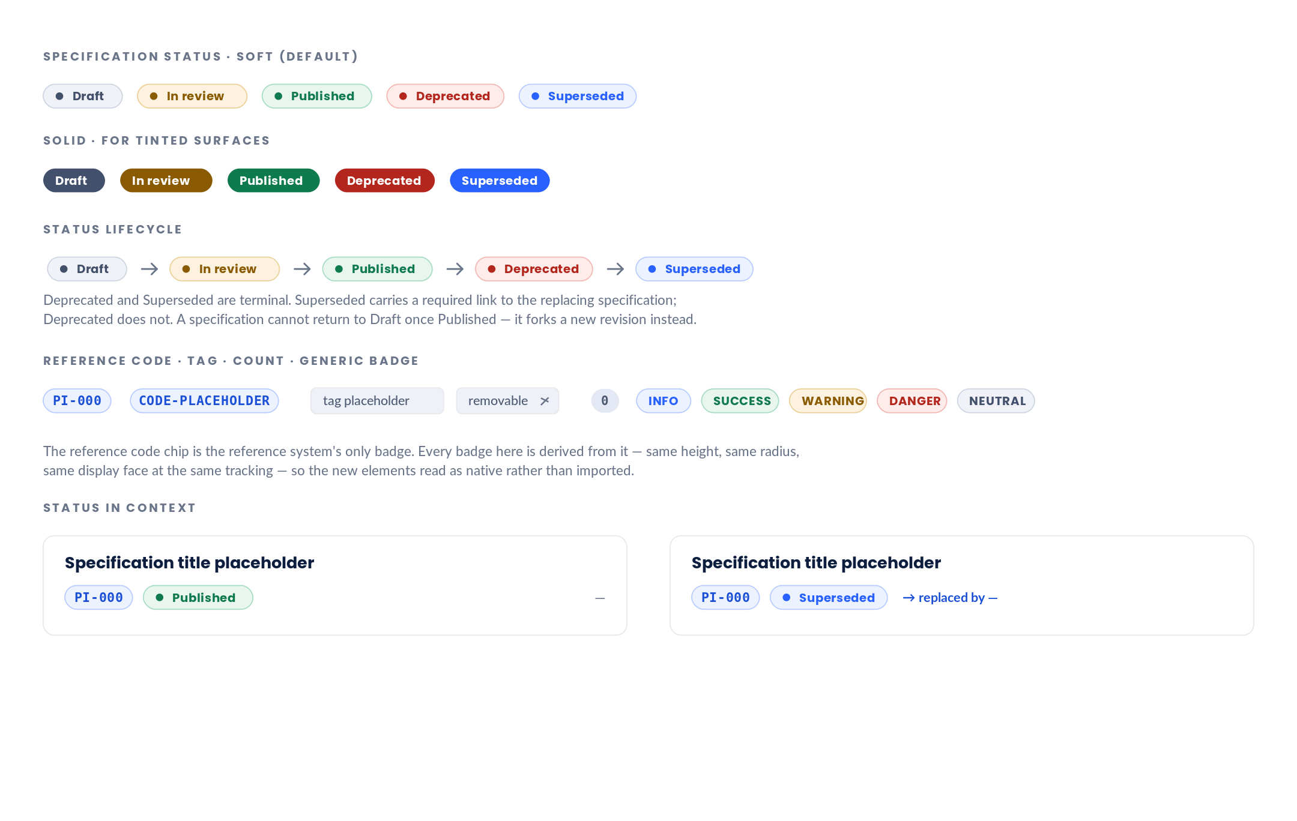
1 The confirmed five-state vocabulary, rendered in both soft and solid forms.  2 A dot precedes each status label so state is not conveyed by colour alone — required by WCAG 1.4.1.  3 The lifecycle is enforced in the data layer, not just drawn. Terminal states cannot transition back to Draft. |  | 4 Superseded requires a link to its replacement. This is the state that matters most for print specifications, where retired versions circulate physically.  5 Tags are visually distinct from status and from category — flat neutral chips, no dot, optionally removable. Three classification axes must never look alike.

S11 Cards
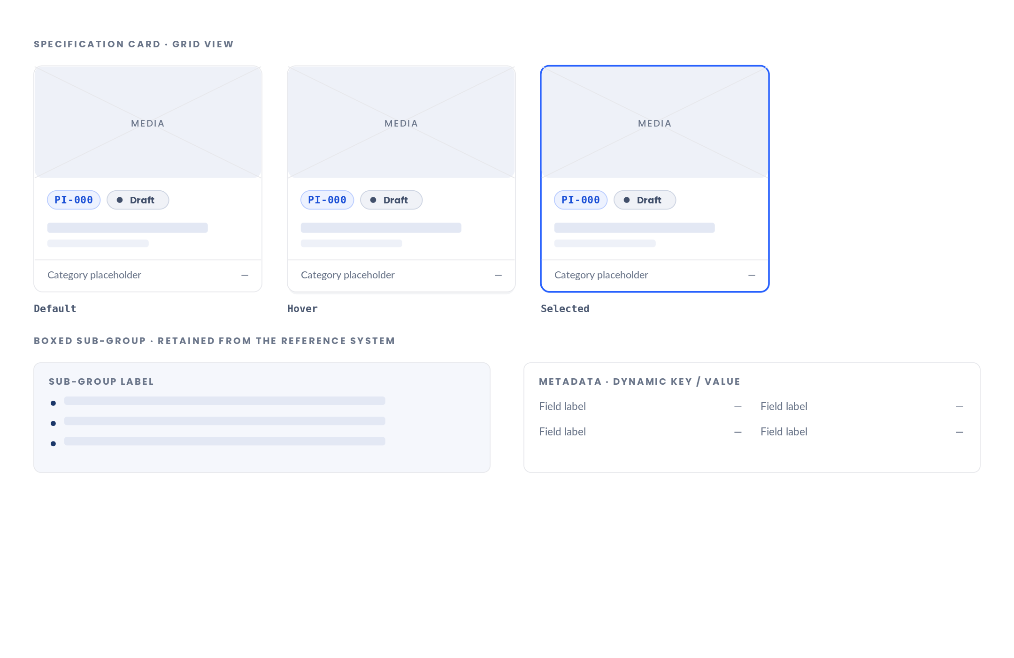
1 The specification card has no precedent in the reference system, which has no grid, no summary card and no related-item card. It is built from the boxed sub-group's materials — same radius, same border, same tint.  2 Hover raises to shadow-1 and nothing else. No scale, no lift beyond 1px. Motion in this system is restrained by design.  3 Selected uses a 2px accent border rather than a fill, so the card's own content keeps its contrast. |  | 4 The whole card is one link target and one focus stop. Nested interactive elements inside a card are prohibited.  5 Metadata renders as dynamic key/value rows — the confirmed structure. Labels are authored per specification or inherited from a category template, so a new field never needs a code change.

S12 Tables
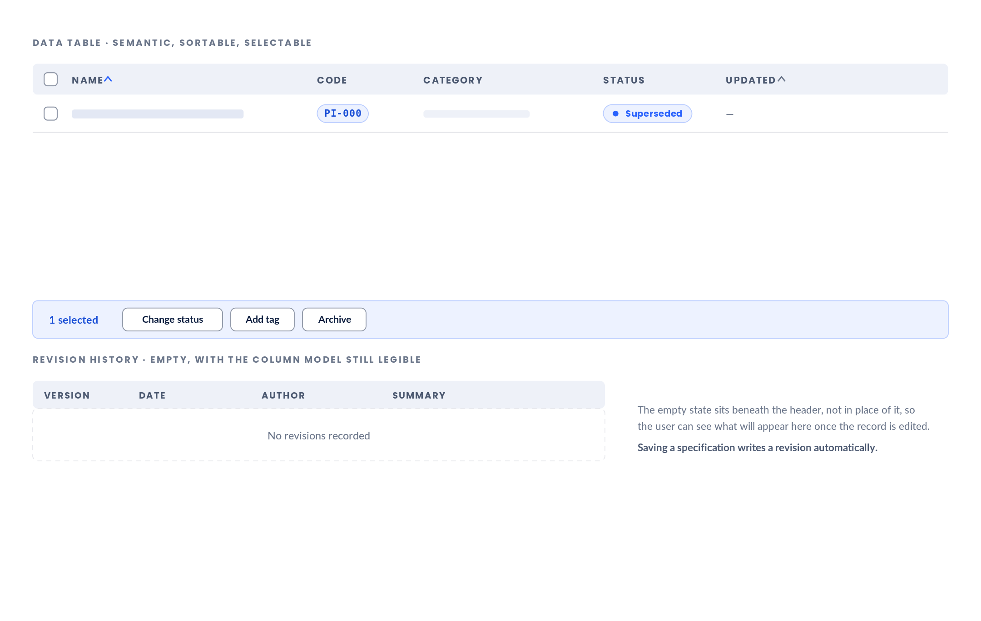
1 Real table semantics — thead, th with scope, and caption. The reference system draws its admin lists as CSS Grid rows, which screen readers cannot announce as rows and columns.  2 Sortable columns carry an indicator and aria-sort. Sorting does not exist in the reference system at all.  3 Selection column with an indeterminate header state, driving the bulk actions bar. |  | 4 Row actions appear on hover and focus, and are always present in the DOM so keyboard users reach them.  5 Below 768px rows become stacked cards rather than scrolling horizontally — shown on Phase 2 plate R5.

S13 Navigation, sidebar, breadcrumbs and tabs
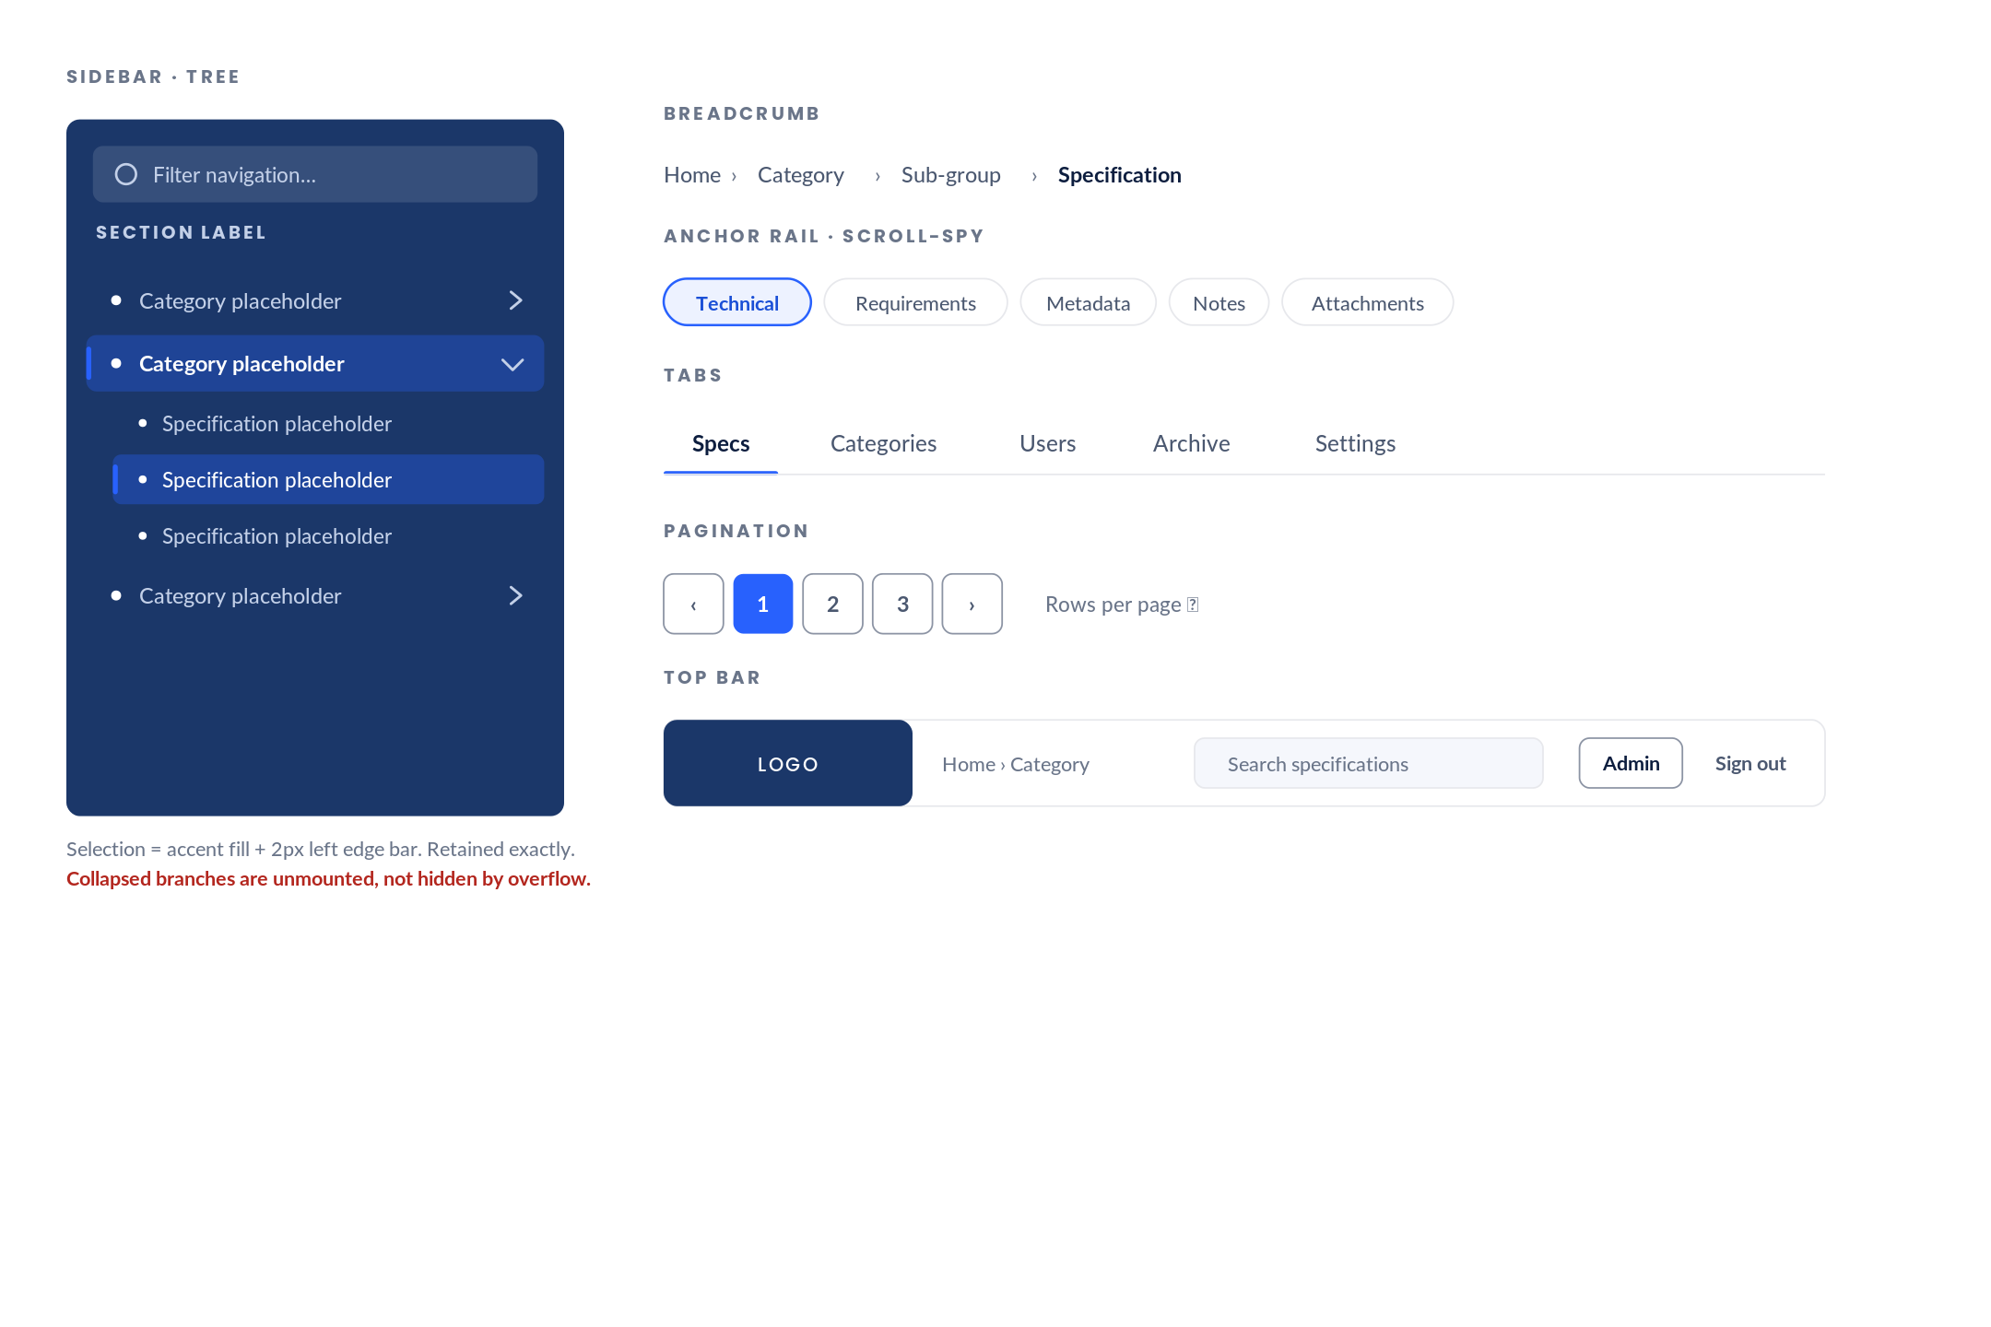
1 The sidebar keeps the reference system's navy surface and its selection marker — accent fill plus a 2px left edge bar — because it is the clearest visual anchor in the product.  2 White-on-navy text is corrected: the section label moves from 45% to a solid tint that reaches AA, and rises from 8.5px to 11px.  3 Collapsed branches are unmounted and the closed drawer is marked inert, so their controls leave the tab order. The reference system leaves them focusable while invisible. |  | 4 Breadcrumbs become a real navigable trail with an ordered list and aria-current. The reference system's strip is decorative and drops its last segment on mobile.  5 The anchor rail is a scroll-spy segmented control — the mechanism that lets twelve sections live in a half-width panel.

S14 Accordions, modals, sheets, tooltips and popovers
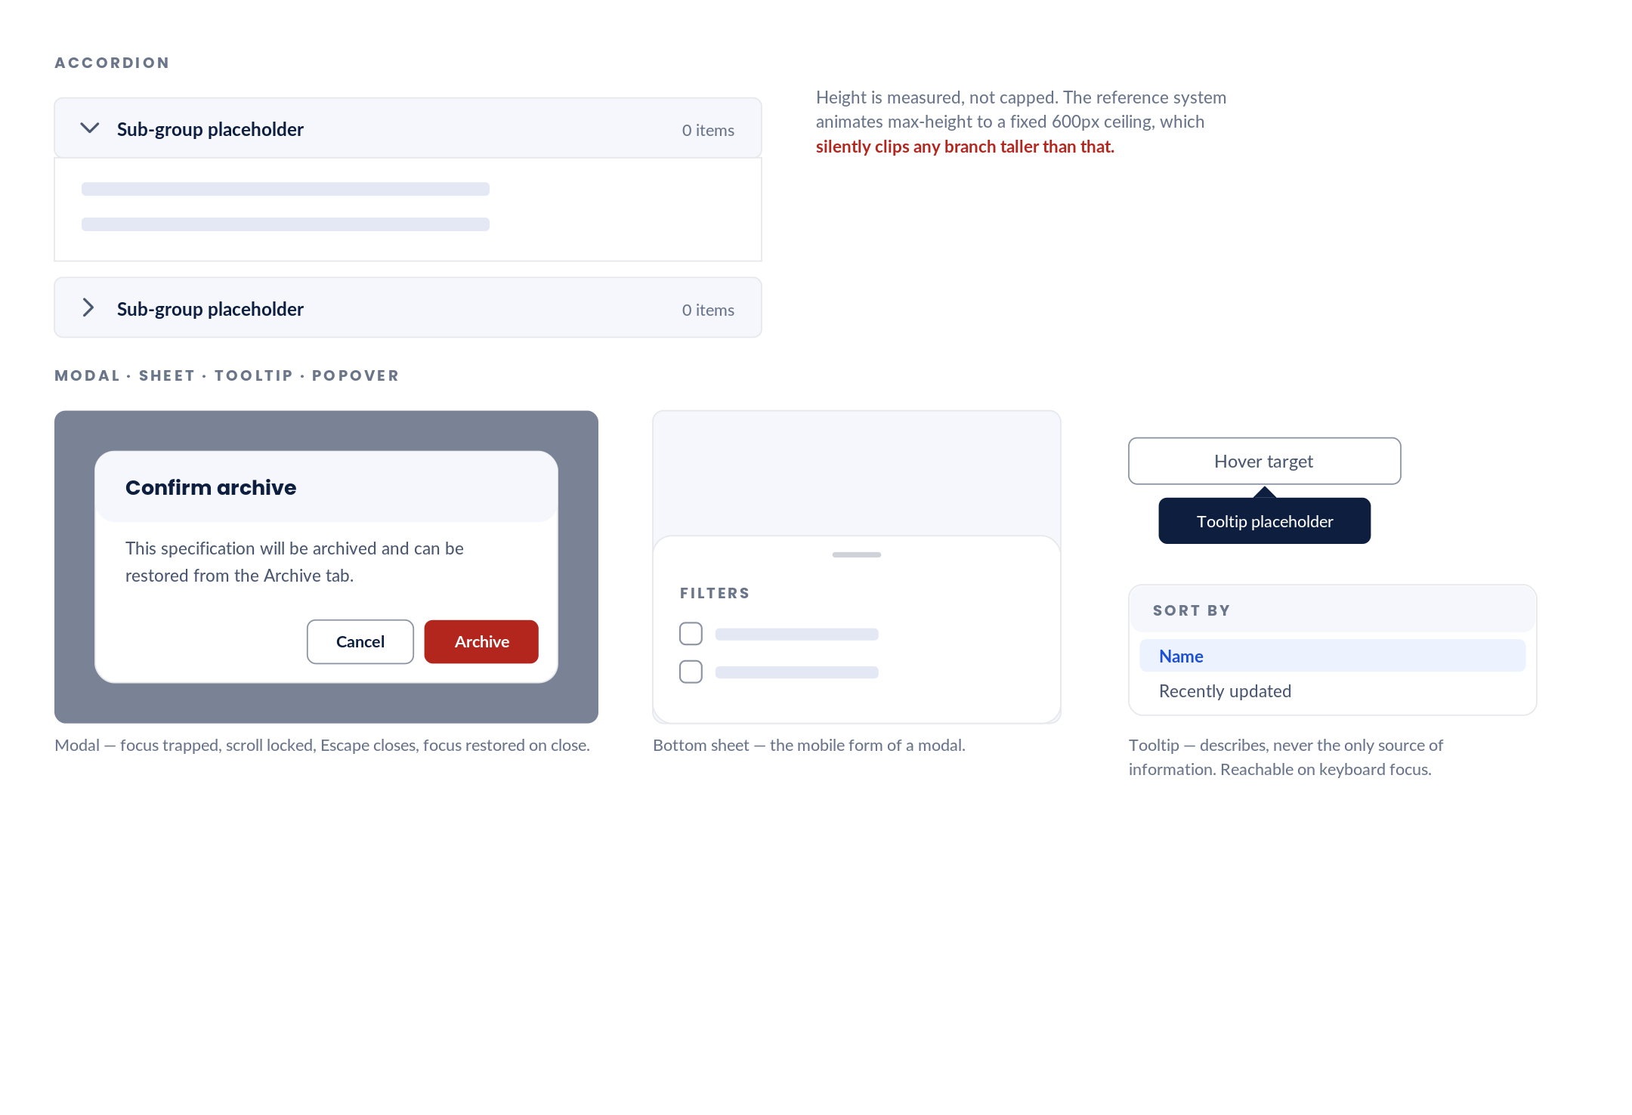
1 Accordion height is measured rather than capped, removing the reference system's 600px clipping ceiling.  2 Modals trap focus, lock background scroll, close on Escape and restore focus to the trigger. None of this is implemented in the reference system's overlays.  3 The bottom sheet is the mobile form of the modal — same component, different presentation, chosen by breakpoint rather than by a separate implementation. |  | 4 Tooltips describe and never carry information available nowhere else. They open on hover and on keyboard focus, and never contain interactive content.  5 Popovers do contain interactive content and therefore take focus, unlike tooltips. Keeping the two distinct is what prevents keyboard traps.

S15 Alerts and toasts
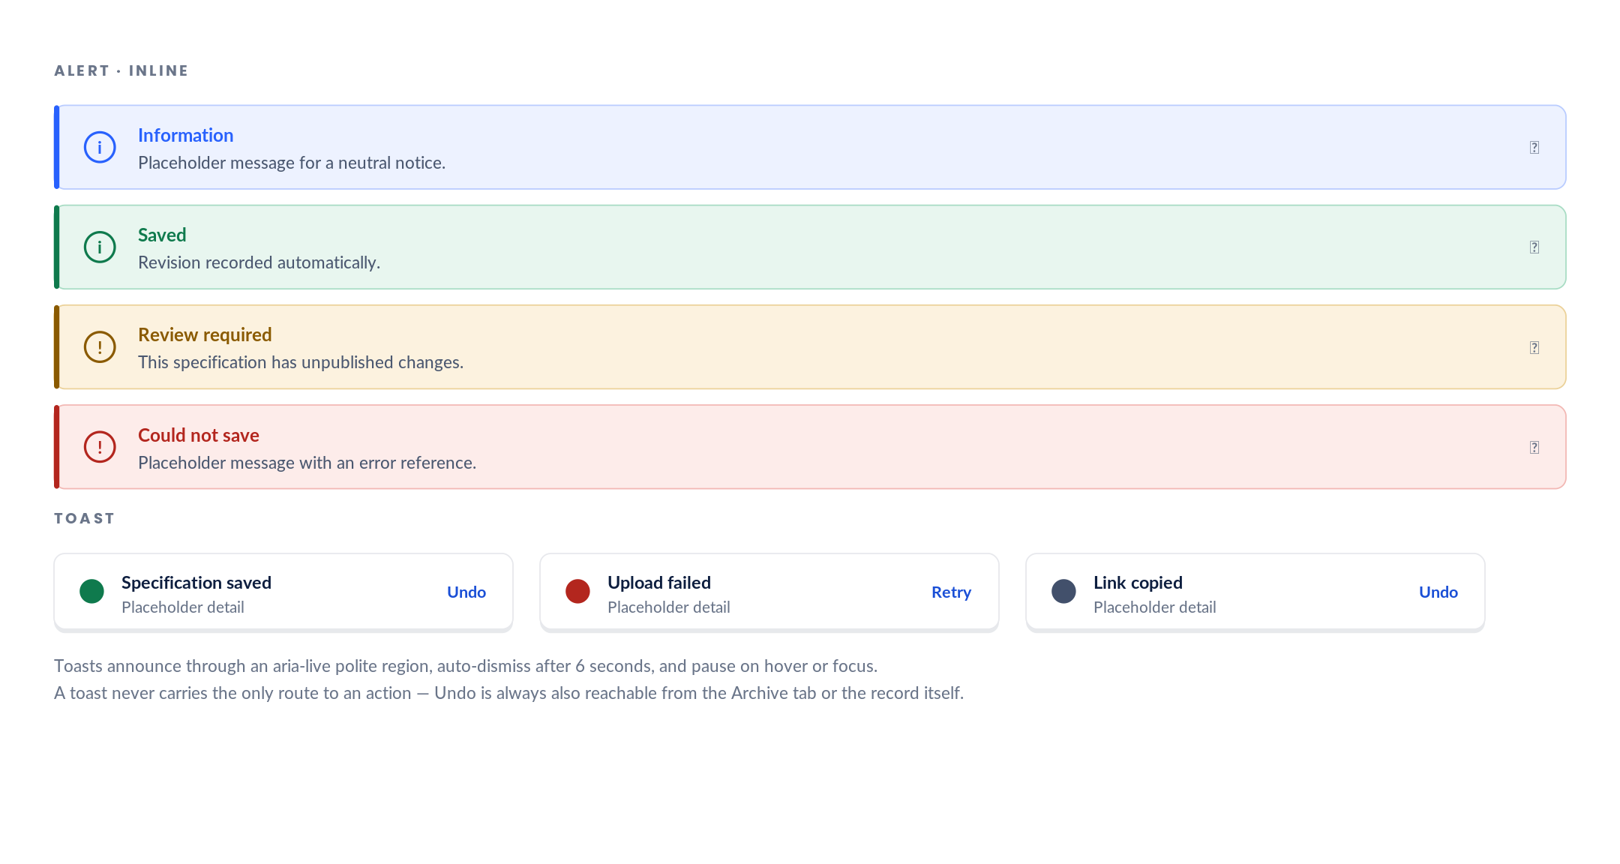
1 Four semantic tones, each with an icon and a coloured leading bar so tone is never conveyed by colour alone.  2 Inline alerts sit in the layout and persist. Toasts float and expire. The two are never interchangeable.  3 Every toast announces politely to assistive technology and pauses its timer on hover or focus. |  | 4 Destructive confirmations use a modal, never a toast — an action that cannot be undone must be confirmed before it happens, not offered an undo after.  5 The reference system has a notification panel but no inline alert and no toast; form errors surface only as browser validation.

S16 Icons
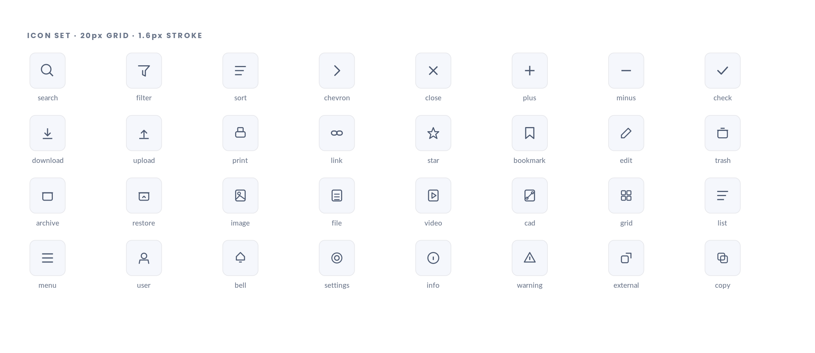
1 Thirty-two icons on a 20px grid with a 1.6px stroke, matching the reference system's stroke weight so they sit correctly beside its type.  2 A single typed Icon component with a required name prop. The reference system writes each icon out inline at its point of use, with no component and no sprite.  3 Decorative icons take aria-hidden. Icon-only buttons take an accessible name — the reference system's icon-only mobile controls have neither. |  | 4 Icons never carry meaning alone. Every icon-only control has a tooltip, and every status icon is paired with a text label.  5 Sizes are 16, 20 and 24, tied to the type size they accompany rather than chosen per instance.

S17 Empty, loading, error and skeleton states
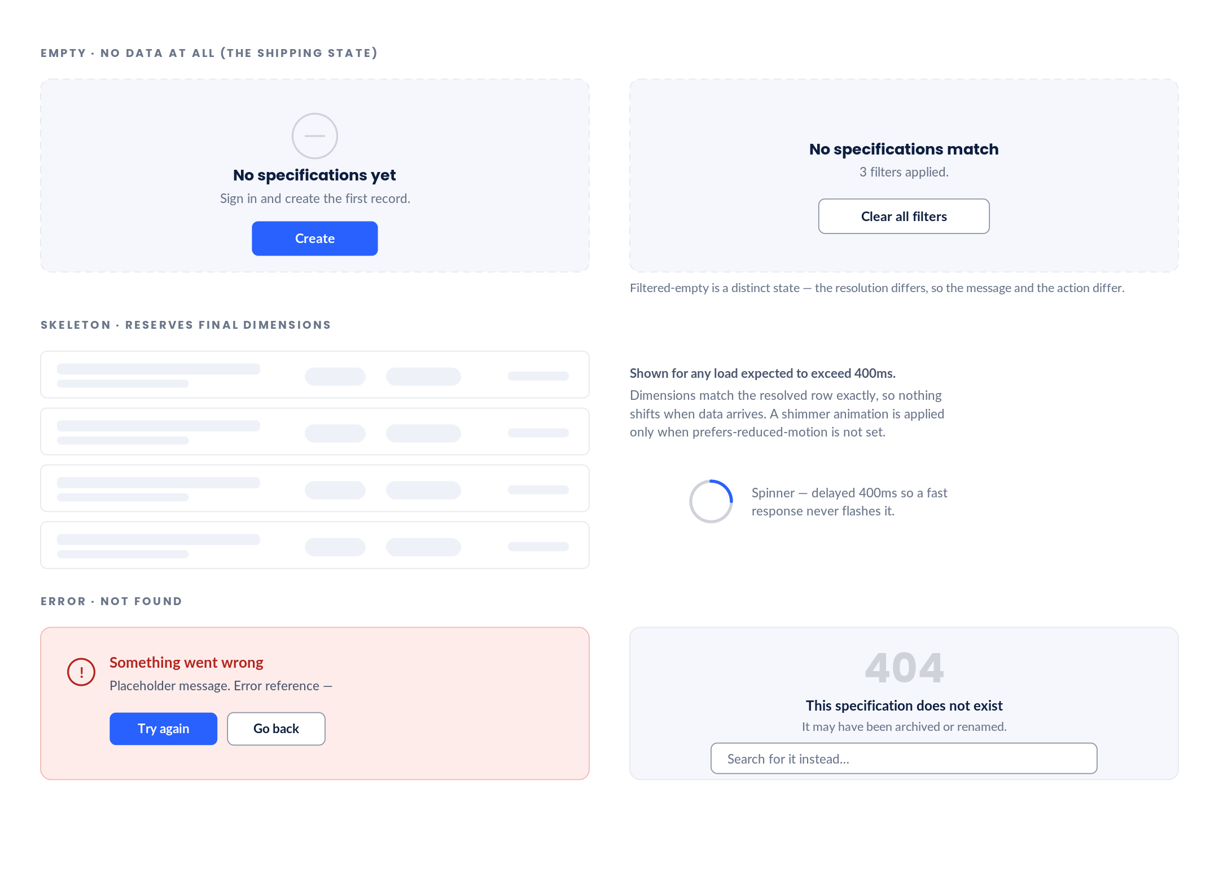
1 Because every specification ships empty, these are not edge cases — for a period they are the primary experience. The reference system defines none of them.  2 Empty-with-no-data and empty-after-filtering are separate components with different messages and different actions.  3 Skeletons reserve the resolved dimensions exactly, so data arrival causes no layout shift. |  | 4 The spinner is delayed 400ms; the skeleton appears immediately. A fast response shows neither.  5 404 offers search rather than only a link home, because a dead specification link usually means the record was renamed rather than removed.

S18 Theme applied — light and dark
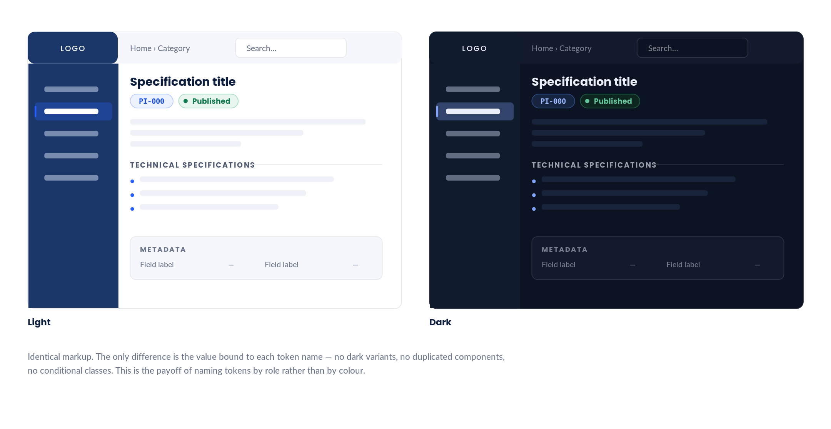
1 The same component tree rendered under both token sets. Nothing in the markup or the component code differs.  2 Dark mode is a Phase 9 requirement in your brief. Because it is derived from the token layer rather than retrofitted, it costs one stylesheet block.  3 The brand navy surface persists in dark mode as the sidebar, so the product's silhouette is recognisable in both themes. |  | 4 Accent and semantic colours shift value but hold their hue, so a Published badge reads as the same thing in either theme.  5 Theme is chosen by a data-theme attribute with prefers-color-scheme as the fallback, and is exposed in the settings tab shown on Phase 2 plate D14.

5. Composition rules
Rules that govern how components combine. These are the ones that break systems when left unstated.

Rule | Why
A card is one link target and one focus stop. Interactive elements are never nested inside it. | Nested interactives inside a link produce an invalid accessibility tree and make keyboard traversal unpredictable.
Only one primary button per view region. | Primary is a claim about the single most likely action. Two primaries is no primary.
Destructive actions are confirmed before they happen, never undone after. | An undo toast is not a substitute for confirmation on an irreversible action. Archive is soft, so it needs no modal; permanent delete is not, so it needs a typed confirmation.
Colour is never the only carrier of meaning. | Every status badge has a dot, every alert has an icon, every sort column has an arrow. WCAG 1.4.1.
Empty states carry the action that resolves them. | The catalogue ships empty. An empty state without a next step is a dead end at the exact moment the user needs direction.
Anything hidden is unmounted or inert, never merely invisible. | The reference system’s collapsed branches and closed drawer stay in the tab order. This is the most common keyboard defect in the product.
Controls relocate on small screens; they are never removed. | The reference system deletes the image-download control below 360px. Function must not depend on viewport width.
Every field label sits above its input, at every breakpoint. | Keeps association unambiguous, keeps touch targets full-width, and removes an entire class of responsive layout bug.
Error message rows are reserved in the layout before an error exists. | Revealing an error must not shift the form under the user’s cursor.
Skeletons match resolved dimensions exactly. | A skeleton that is the wrong size causes the layout shift it was introduced to prevent.
Tooltips describe; popovers contain. Tooltips never hold interactive content. | A tooltip with a button in it is unreachable by keyboard and is the classic source of focus traps.
Saving a specification always writes a revision. | History that depends on the author remembering to record it will not be maintained.

6. Accessibility conformance
Target: WCAG 2.1 Level AA. Every Phase 1 finding is resolved at the system level rather than per component.

Criterion | Obligation | How this system meets it
1.4.1 Use of colour | Colour is not the sole means of conveying information | Status badges carry a dot, alerts carry an icon and a leading bar, sortable columns carry a direction arrow.
1.4.3 Contrast (minimum) | Text reaches 4.5:1, large text 3:1 | Solved rather than chosen. All 74 pairings verified; report regenerated from source.
1.4.4 Resize text | Text scales to 200% without loss of function | Every size is in rem against a 16px root. Type floor raised from 8px to 11px.
1.4.10 Reflow | No horizontal scroll at 320px / 400% zoom | The shell scrolls internally without locking the document. The reference system sets overflow:hidden on html and body, which prevents reflow entirely.
1.4.11 Non-text contrast | UI component boundaries reach 3:1 | border-control is a distinct token solved at 3.05:1, used on every input and secondary button.
1.4.12 Text spacing | No loss of content when spacing is overridden | No fixed heights on text containers; the specification row and section label both flow.
2.1.1 Keyboard | All functionality available from a keyboard | Command palette, roving tab index in the tree, full menu and tabs patterns, arrow-key groups.
2.1.2 No keyboard trap | Focus can always leave a component | Tooltips hold no interactive content; modals trap deliberately and release on Escape.
2.4.1 Bypass blocks | A mechanism to skip repeated content | SkipLink is the first focusable element on every page, targeting the main landmark.
2.4.3 Focus order | Focus order preserves meaning | Collapsed accordions and the closed drawer are unmounted or inert, so they leave the tab order.
2.4.7 Focus visible | Keyboard focus is visible | A single :focus-visible primitive — 2px ring, 2px offset. The reference system suppresses outlines without replacing them.
2.5.5 Target size | Touch targets are at least 44×44 | Every control reaches 44×44 through padding at touch widths without changing its visual height.
3.3.1 Error identification | Errors are identified in text | Field errors use aria-invalid and aria-describedby; the message row is reserved before it is needed.
3.3.2 Labels or instructions | Inputs carry labels | The Field wrapper guarantees association. Placeholder is never the label.
4.1.2 Name, role, value | Components expose correct semantics | Real tables, real dl for metadata, real dialog semantics, aria-current on breadcrumb and anchor rail.
4.1.3 Status messages | Status is announced without focus change | Toasts and result counts announce through polite live regions.

Reference system audit — the measured baseline
Computed from the values as found in the published stylesheet. Every figure below is produced by the same function that generates the shipped contrast report.

Pairing | Ratio | Required | Result
--txt on white (body) | 16.48:1 | 4.5:1 | PASS
--txt2 on white (secondary, 55%) | 3.8:1 | 4.5:1 | FAIL
--txt3 on white (tertiary, 35%) | 2.17:1 | 4.5:1 | FAIL
--acc on white (links, codes) | 4.98:1 | 4.5:1 | PASS
--navy on white (headings) | 11.69:1 | 4.5:1 | PASS
--txt2 on --bg1 (secondary on tint) | 3.52:1 | 4.5:1 | FAIL
--txt3 on --bg2 (placeholder on tint) | 1.92:1 | 4.5:1 | FAIL
nav section label, white 45% on navy | 3.67:1 | 4.5:1 | FAIL
nav sub-item, white 60% on navy | 5.28:1 | 4.5:1 | PASS
nav item, white 75% on navy | 7.31:1 | 4.5:1 | PASS
--red on white (destructive) | 3.27:1 | 4.5:1 | FAIL
--line3 border on white | 1.59:1 | 3:1 | FAIL

7. Token delivery
The design system ships as files, not only as a document. These are in your project folder now, under design-system/tokens, and Phase 5 consumes them directly.

File | Contains | Consumed by
tokens.css | Every token as a CSS custom property. Light set on :root, dark set on [data-theme="dark"] and under prefers-color-scheme. Includes the reduced-motion block and the :focus-visible primitive. | Imported once at the application root.
tailwind.tokens.js | Tailwind theme bridge. Colours, spacing, radii, shadows, type, screens, z-index and containers all resolve to the CSS variables above. | Spread into tailwind.config.js. Because values are variables, no dark: variants are needed anywhere.
tokens.ts | TypeScript literal unions for colour, type, spacing and radius tokens, plus the specification status list and breakpoint map. | Component prop types, so an invalid token is a compile error rather than a silent fallback.
CONTRAST-REPORT.md | The full computed verification — reference-system audit plus every pairing in both new palettes. | Regenerated from source. If a token changes and a pairing fails, the report says so.

7.1 Why this matters for Phase 5
The reference system’s design decisions live inside an 80KB HTML file alongside its content, which is why they cannot be reused. Extracting them into typed, verified files is what turns this from a redesign of one site into the reusable platform your brief asks for. A future category, a future theme, or a future consumer of these tokens needs no code change.

8. Phase 4 scope & approval
On approval, Phase 4 produces the data model — deliverable 9. Reusable, fully typed, entirely empty.

8.1 Scope
- Specification — Identity, status, category and sub-group references, description, tags, technical specifications, requirements, dynamic metadata, notes, media, attachments, downloads, related specifications, revision history, timestamps and authorship.
- Category — Name, slug, description, order, media, optional sub-groups, and a metadata field template that new specifications inherit.
- Sub-group — Nullable middle tier. Name, slug, order, parent category.
- Tag — Name, slug, colour tone, usage count. Many-to-many, unordered, never navigable as a tree.
- Status — The five confirmed states with permitted transitions encoded, so the lifecycle is enforced rather than drawn.
- Revision — Version, timestamp, author, summary, and a diff of the changed fields.
- Attachment / Download — Filename, kind, size, MIME type, dimensions where applicable, storage key.
- Metadata field — Key, label, value, type, order. Dynamic per the confirmed decision.
- User / Role — The four roles named in the admin plates: Viewer, Editor, Approver, Administrator.

8.2 What Phase 4 will not do
It will not populate anything. Every model ships with empty values — empty strings, empty arrays, empty objects — exactly as your brief specifies. The seed data will be a single empty catalogue with no categories and no specifications.

8.3 Decisions needed
- Reference code format. The plates use PI-000 as a placeholder. Is the code authored, or generated from a category prefix and a sequence?
- Whether a specification can belong to more than one category. The current model says no — category is the exclusive primary axis and tags carry everything else. Confirm.
- Whether revision history records field-level diffs or only a summary. Field-level is more useful and more work.

8.4 Approval
If any foundation in Section 2 is wrong, it is far cheaper to change here than after fifty-nine components are built on top of it. The corrected palette in particular changes the smallest type sizes and the lightest text colours from the reference system — plate S3 shows exactly what that looks like side by side.

End of Phase 3. Deliverables 7–8 of 12 complete. Awaiting approval to proceed to Phase 4.

